**2. SPATIAL RISK FACTORS DEPENDENCY WITH DISTRIBUTION PATTERN OF CHOLERA CASES**

**2.1. Distribution of Cholera Cases**

The spatial distribution of 2017-2018 cholera outbreak, shows that the outbreak hits mostly the eastern part of the district. The linear distribution pattern that follows the surface water of Lake Malawi, Songwe river, Lufira river, North Rukuru river and Wovwe river. Figure 1 shows the spatial distribution of 2017-2018 cholera cases.

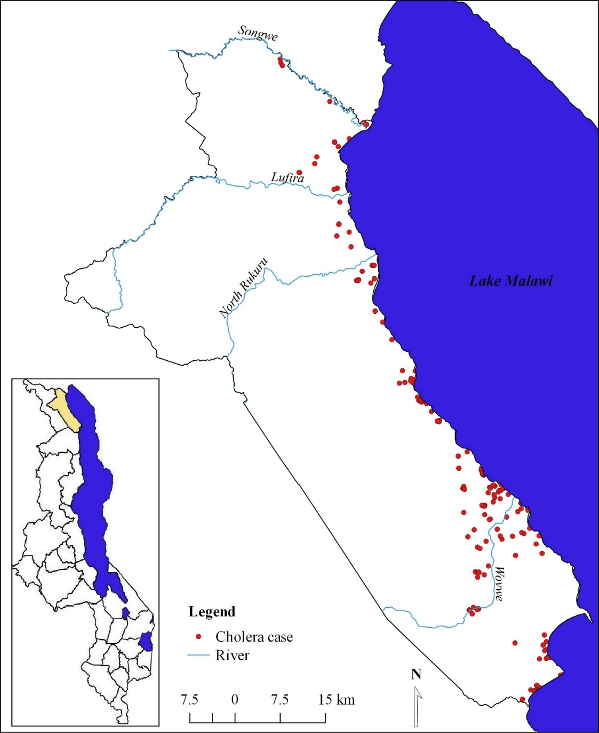

**Figure 1:Distribution pattern of 2017-2018 cholera cases: Karonga district**

**2.2. Spatial dependency of cholera incidence and elevation**

Figure 2 shows the results of Moran’s I calculation and its statistical significances for cholera prevalence in association with elevation. The spatial autocorrelation (Moran’s I) statistical analysis shows a positive and statistically significant spatial autocorrelation for dissimulative incidence rate of cholera cases from lower elevation interval to high elevation interval (Moran's Index = 0.714228, p-value = 0.000000). The p-value shows a strong clustering pattern of cholera incidence and change of elevation which clustering of high rates of cholera cases at the low lands part of Karonga district.

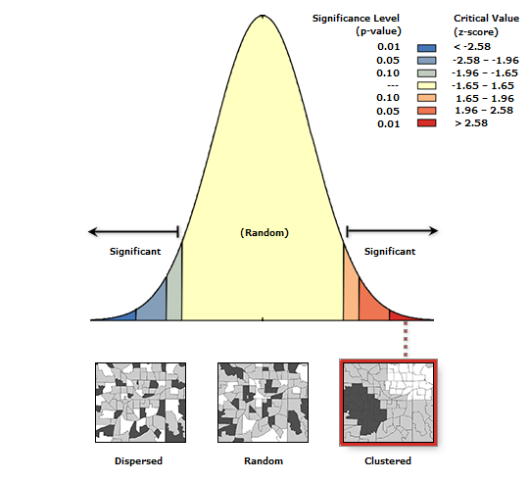

**Moran's Index**: 0.714228

**z-score**: 10.380395 c:\program files (x86)\arcgis\desktop10.6\ArcToolbox\Scripts\Images\clusteredBox01.png

**p-value**: 0.000000

**Figure 2: Spatial Autocorrelation for cholera incidence and Elevation**

Given the z-score of 10.3803954895, there is a less than 1% likelihood that this clustered pattern could be the result of random chance. The spatial relationship based of the counts of cholera cases within defined elevation interval was plotted. The relationship shows that high cholera cases were registered in low lands with elevation less than 300m altitude and low cholera cases in high lands with elevation interval of 601m – 900m altitude. Figure 3 shows the relationship between change of elevation and rates of cholera cases.

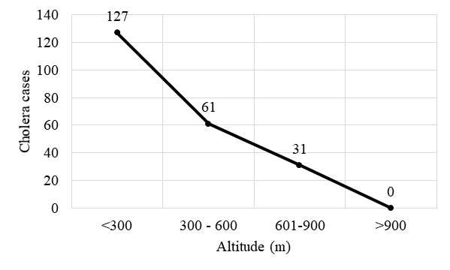

**Figure 3: Relationship between elevation interval and number of cholera cases**

**2.3. Proximity analysis of cholera cases from surface water**

Evaluating the clustering of cholera cases homes for fixed distance buffer in reference to surface water sources was typically implemented using count statistics for numeric fields. The proximity analysis based on distance of patients homes to the surface water shows that the majority (count: 90) of cholera cases are within < 0.5km buffer. Of 129 spatially collected cholera cases, 42, 37, 14, 13 cholera cases and within 0.5 – 1km, 1.1 – 1.5km, 1.6 – 2km and 2.1 – 2.5km buffer respectively. The proximity analysis based of fixed distance buffer shows that as the offsite distance increases from the surface water, the number of cholera cases decrease. However, the proximity analysis validates spatial autocorrelation which shows an offsite decrease of cholera cases from the surface water source. Figure 4 shows the association of elevation and cholera prevalence in Karonga district.

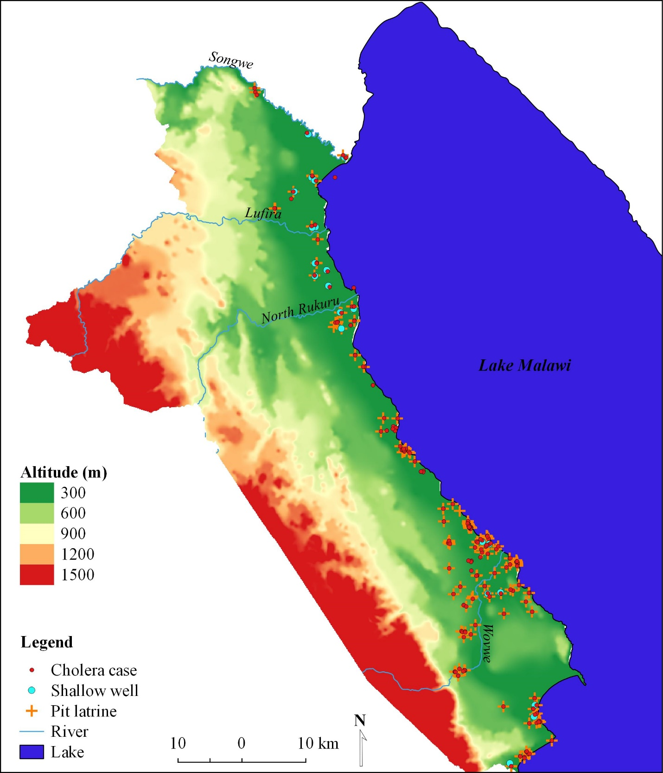

**Figure 4: Spatial Association of Elevation and 2017-2018 cholera prevalence**

**3.4. The role of elevation on the flow direction of microbiological contaminants of surface water source associated with pit latrine**

Figure 5 shows the results of the flow direction analysis of microbiological contaminants from temporary pit latrines in reference to elevation levels. Using hydrology analysis tool for ArcGIS based on flow direction, indicates that microbiological contaminants (bacteria) from pit latrines flow in eastern direction towards low lands of Karonga district. A total sum of 341378 pixels flow direction, 212979 pixels show flow direction towards the surface water source of Lake Malawi, Wovwe river and Songwe river. The topography of the district has cumulative water points in the high lands in which 128399 flow direction pixels converge.

The spatial analysis indicates a positive significance of surface water sources contamination with microbiological from pit latrines. This means the high lands of the district influences the flow direction of microbiological from pit latrines to the low lands which contaminants surface water sources.

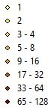

Pixel flow

direction

Point flow

direction

Arrow flow direction: *Microbiological contaminants flow direction*

**Figure 5: Spatial association of elevation, pit latrines, flow direction of microbiological contaminants and surface water sources**

.